**USER MANUAL**

***Note: Please perform these operations on the login page of our real estate website:***

* Manually delete the browser cache.
* Ctrl+Shift+R: To hard reload the page
* Ctrl+f5

***Note: You will need to login with following username and password because we have implemented email notifications and user activation from the admin’s side.***

***User:***

***Username: neel***

***Password: user***

***Admin:***

***Username: neeladmin***

***Password: admin***

**Settings.py:**

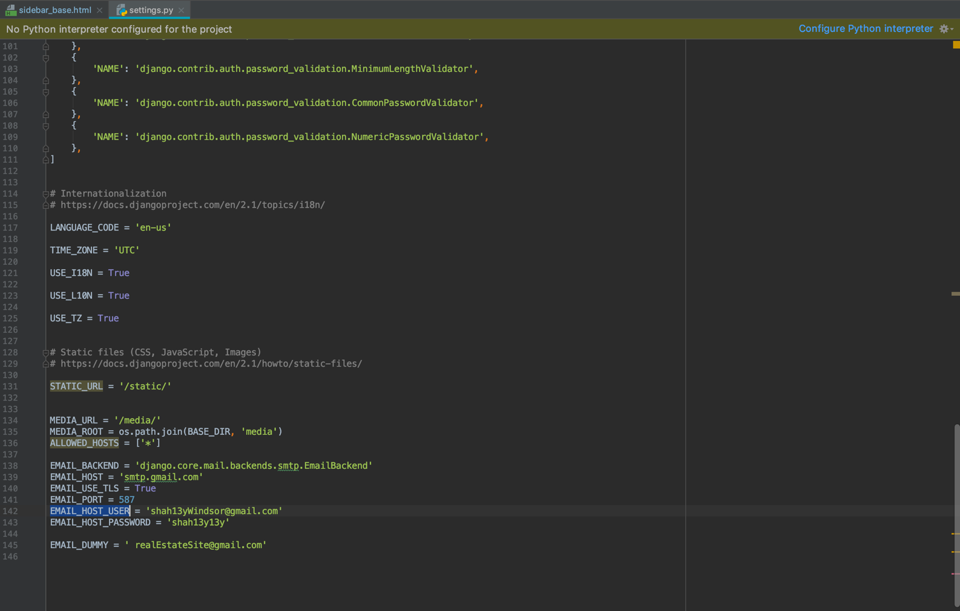

This is the settings.py where as you can see in the screenshot you have to provide hostname and the password for the website admin. Here you will receive all the emails regarding which users are trying to Signup.

**Sign Up:**

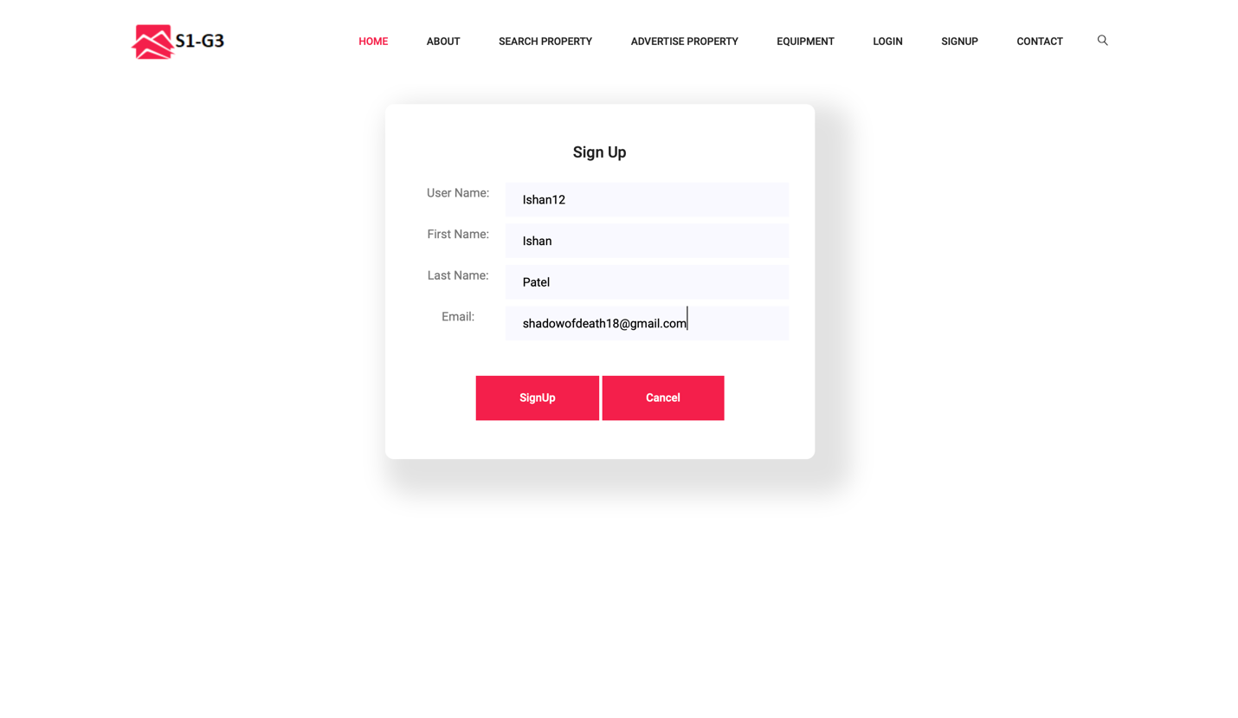

Once a user Signs up on the website this the what they will see initially. Here as a sample we have created a username as Ishan12.

**Login Email Notification:**

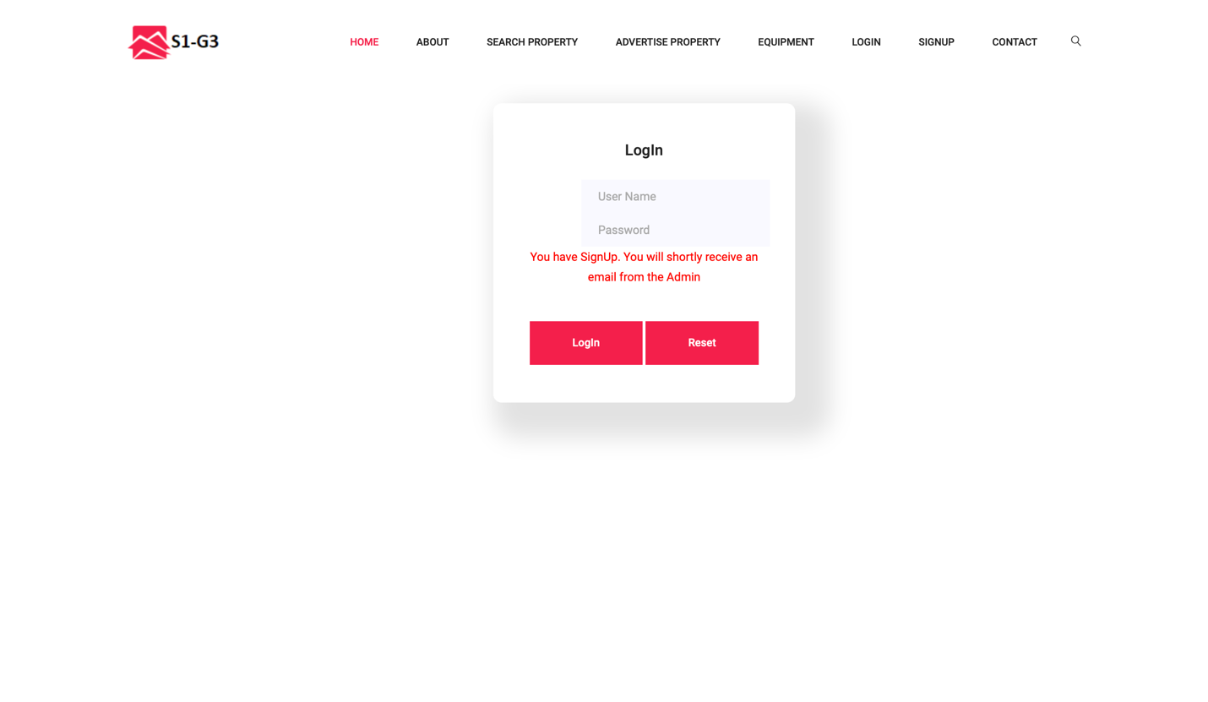

Once the user signed up on the website they will see something like this and an email would to be sent to the Administrator stating that the username with Ishan12 has signed up on the page.

**Email :**

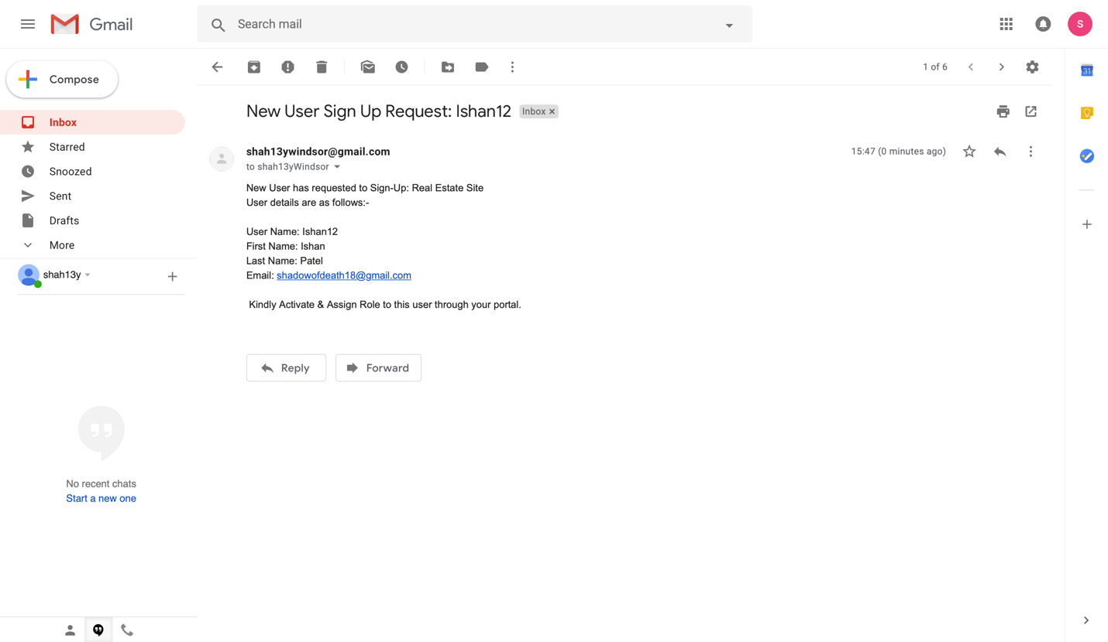

This is what the administrator will see on their email account. As you can see the system has generated a message/email saying all the information of the user. Next step would be for admin. Whether the admin wants to activate the user or not. For that the admin has to log in to their account and see all the users in system.

**Login Successful:**

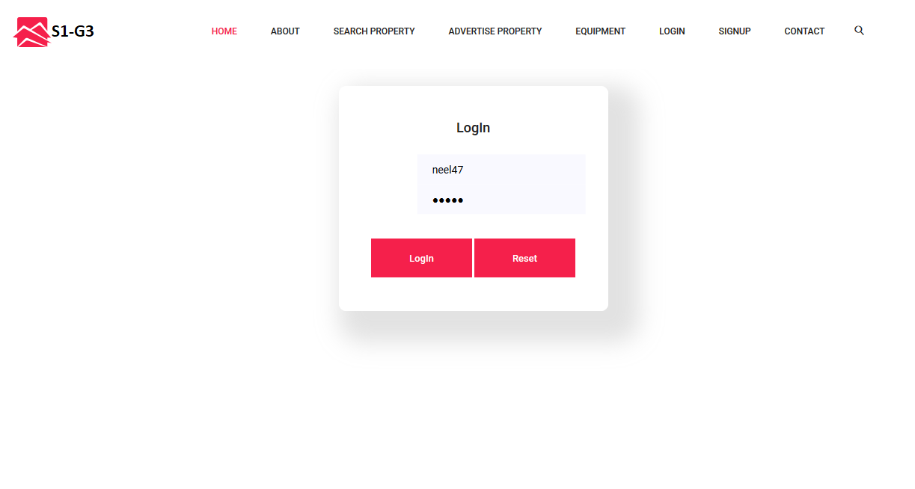

As you can see this is what the admin login page would look like.

**User List:**

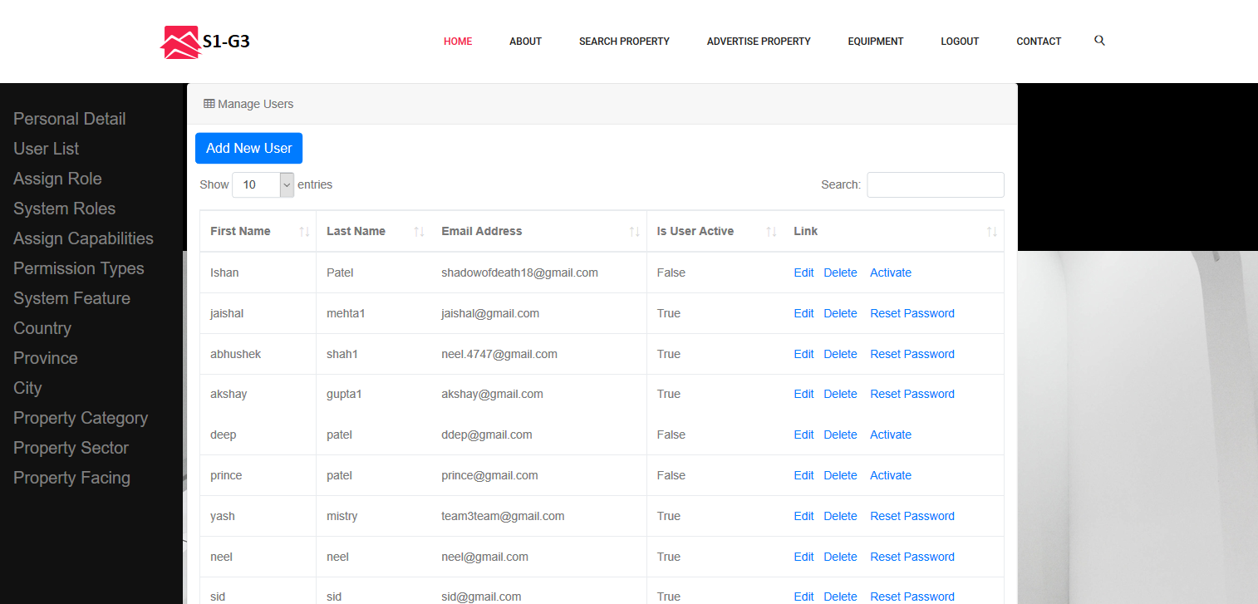

As you can see over here, We have list of all users. Here user named as Ishan’s account is not activated. The admin can activate it.

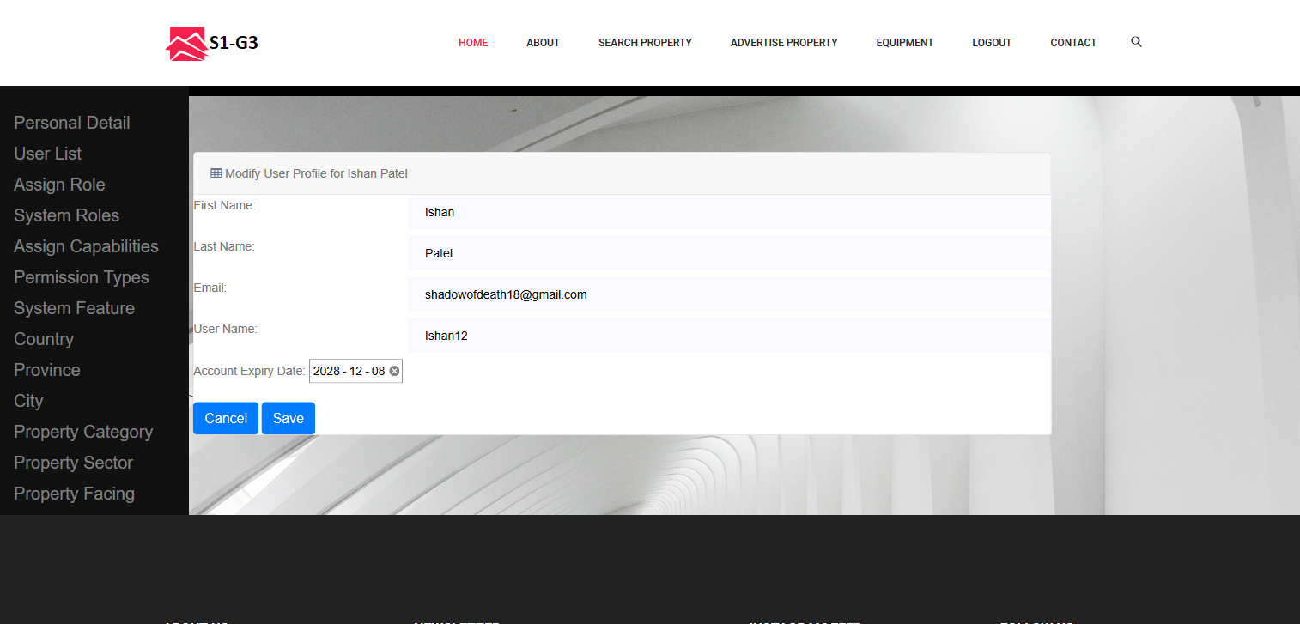

The admin can also change the user details as per requirement and can also set an expiration date on the account.

**Invalid Login details:**

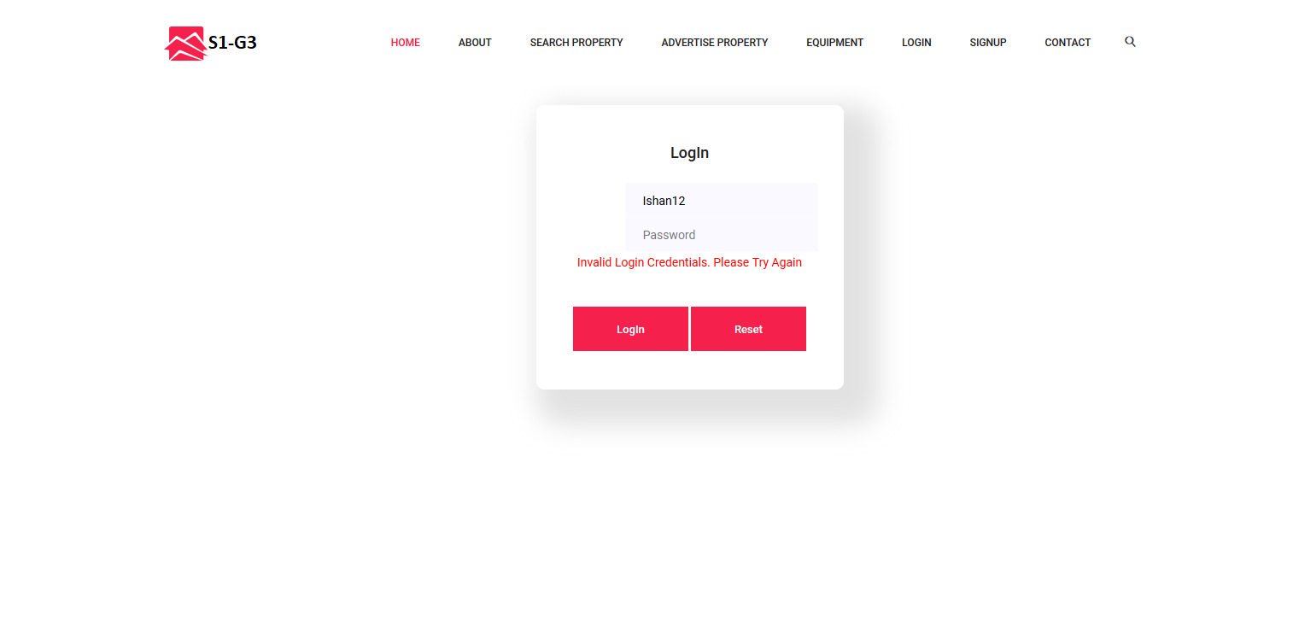

**Role Not Assigned:**

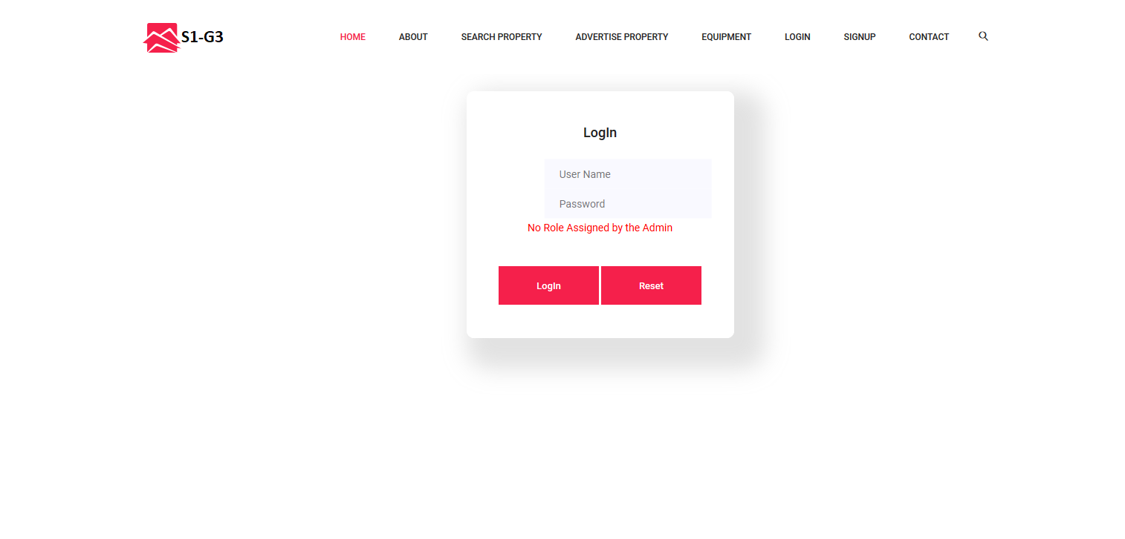

After the user account has been activated by the admin. The user can login to the account. On the first try the user would see something like this which states that the admin has to assign some role to the user named “Ishan12”.

**Assign Role:**

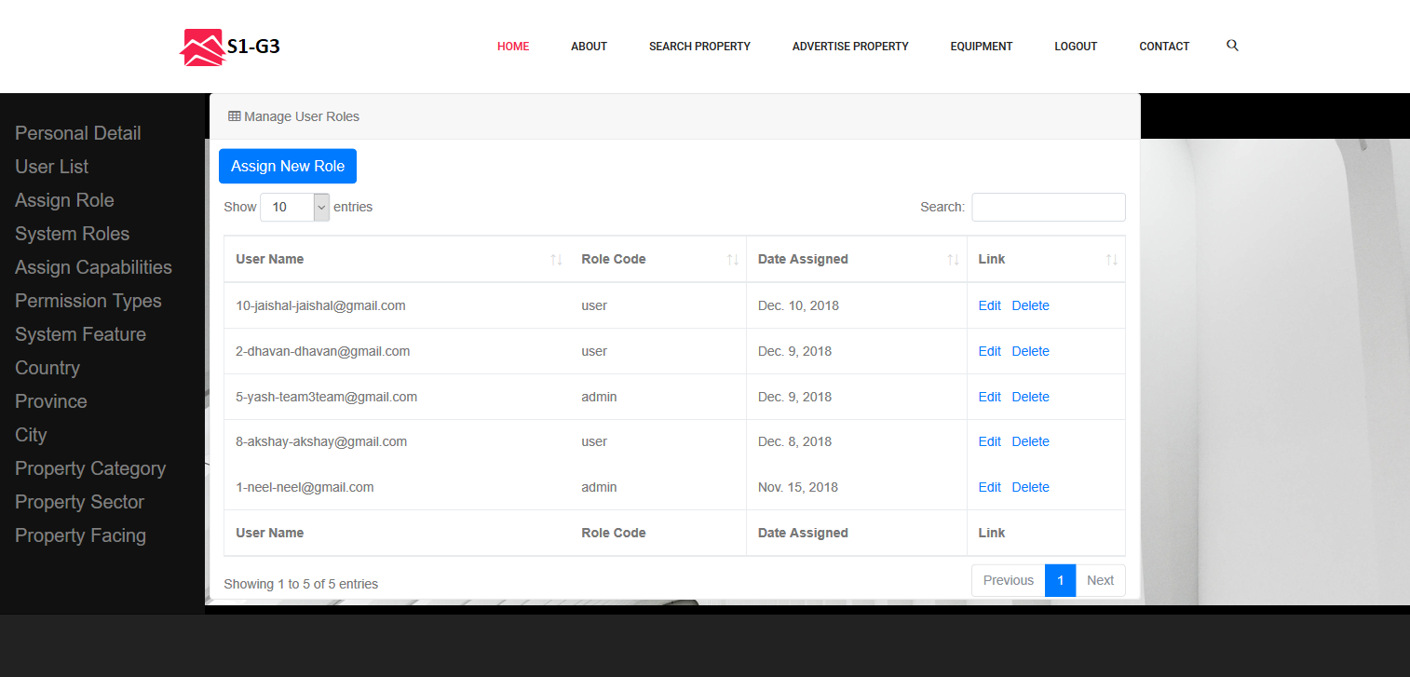

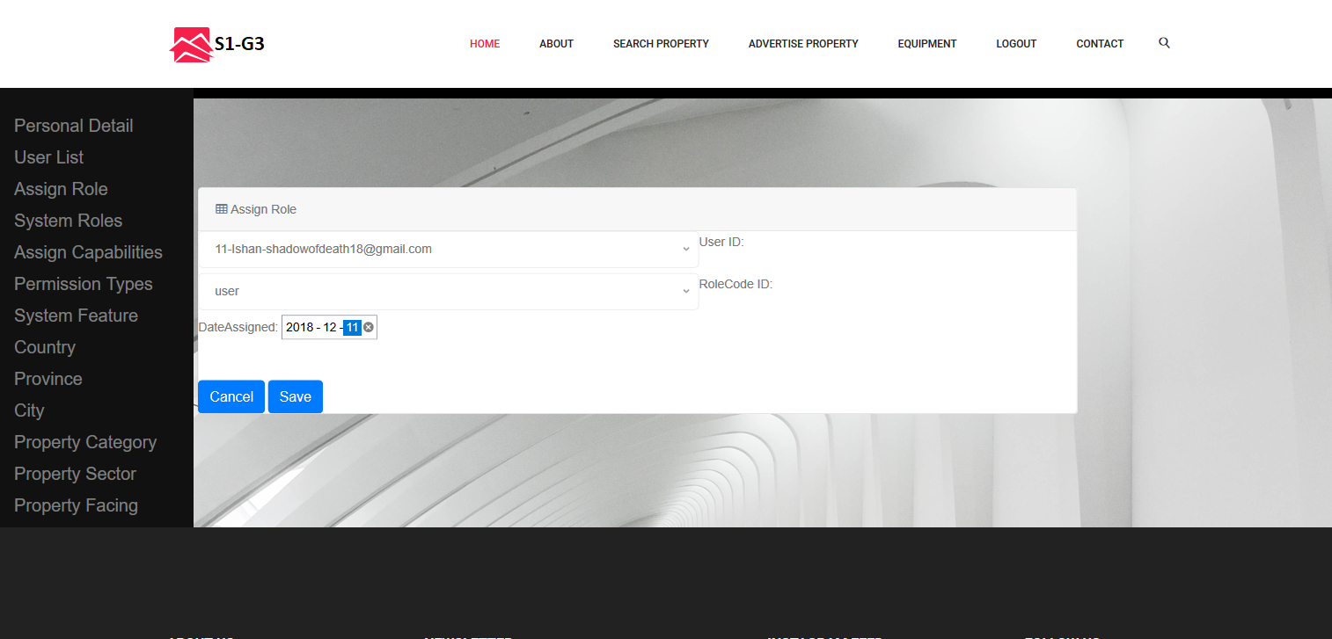

The admin logs in to their account and click on the assign Role tab and can see a page such as this. Here we have assigned “user” role to the user named “Ishan”

**Email Notification:**

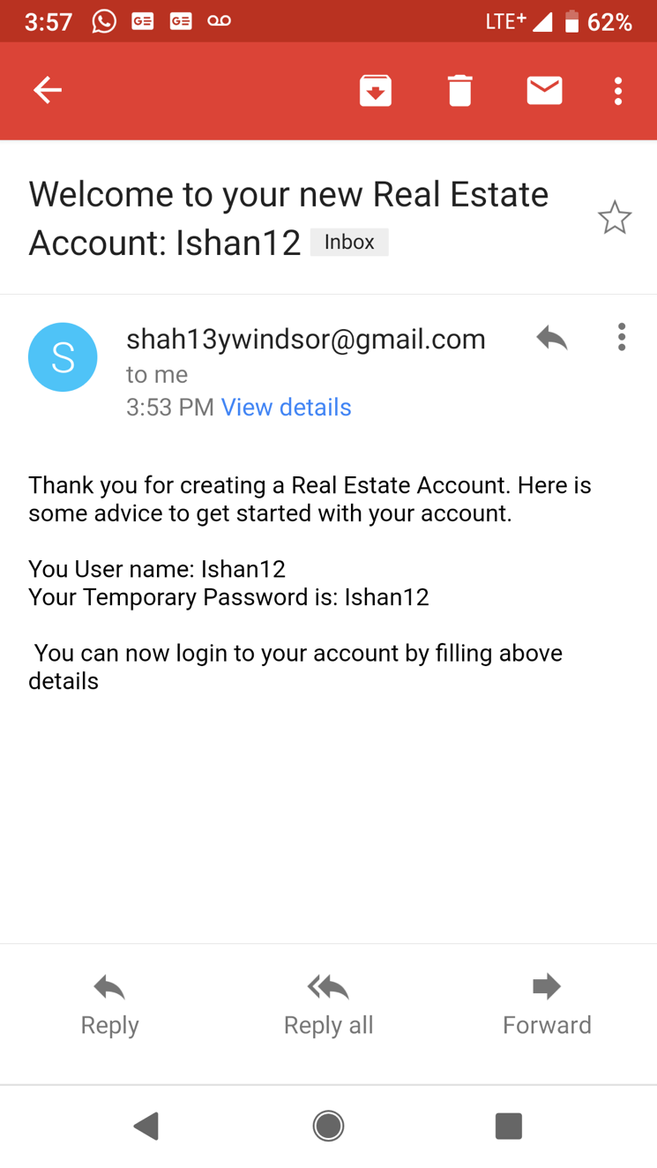

Email would be sent to the user with their username and password after the admin has activated their account.

**Login:**

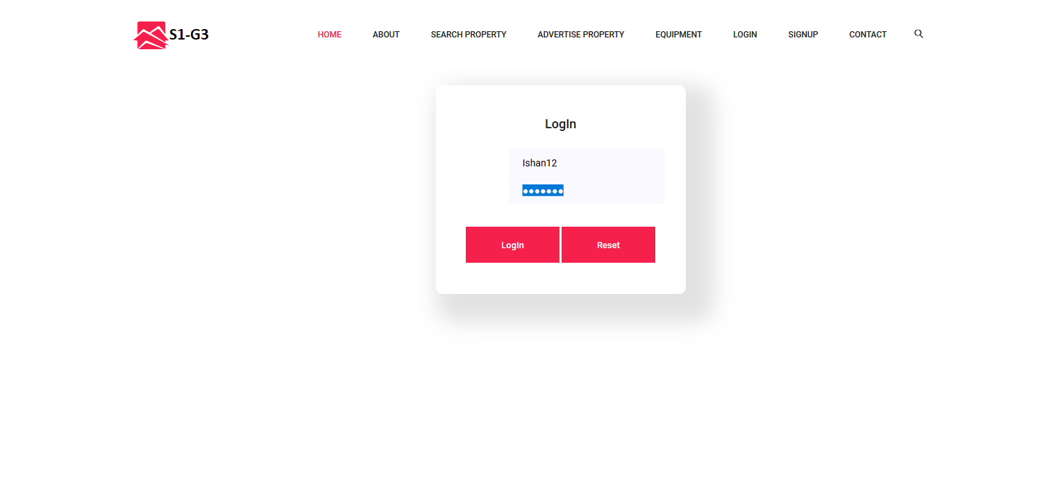

The user Logs in to his/her account.

**Change Password:**

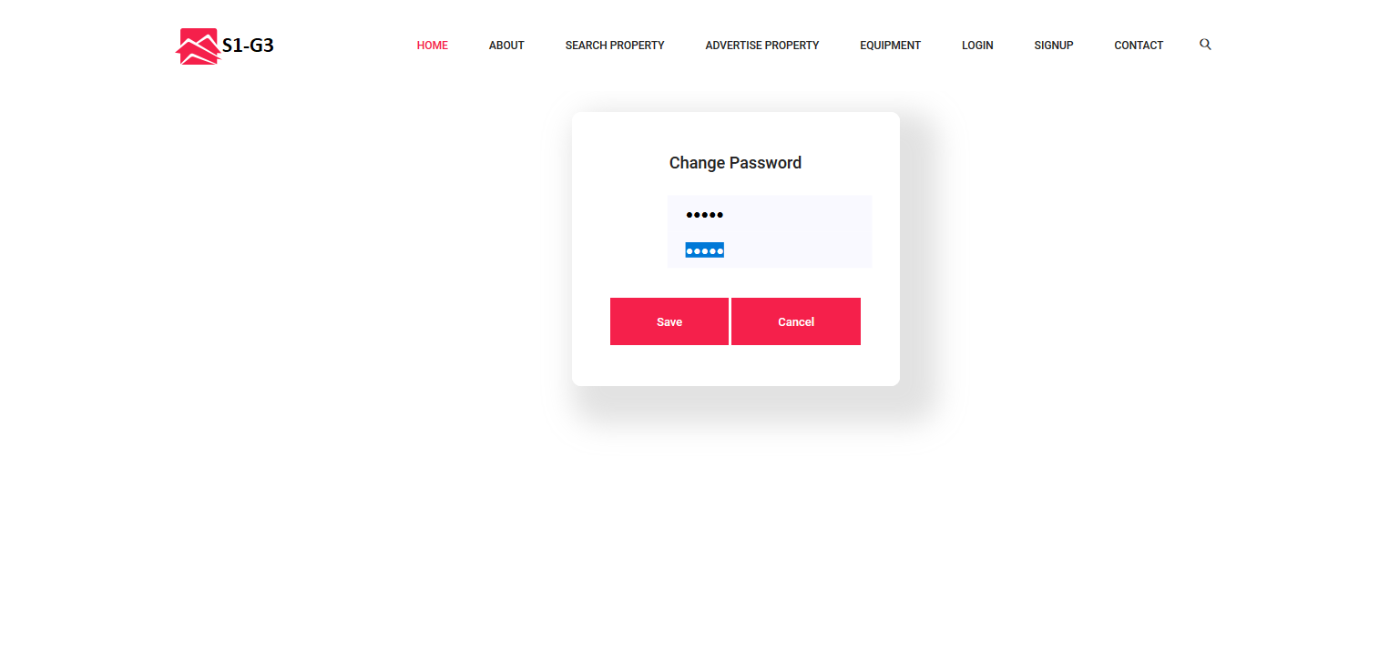

On the first Login the user would be required to change the password. Which was initially same as the username.

**Personal Details:**

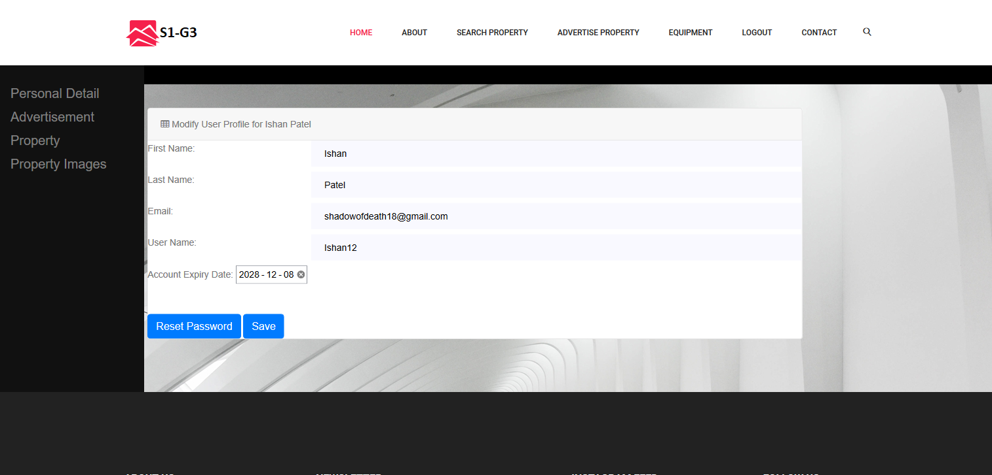

The user can view their personal details and modify accordingly.

**Advertisement:**

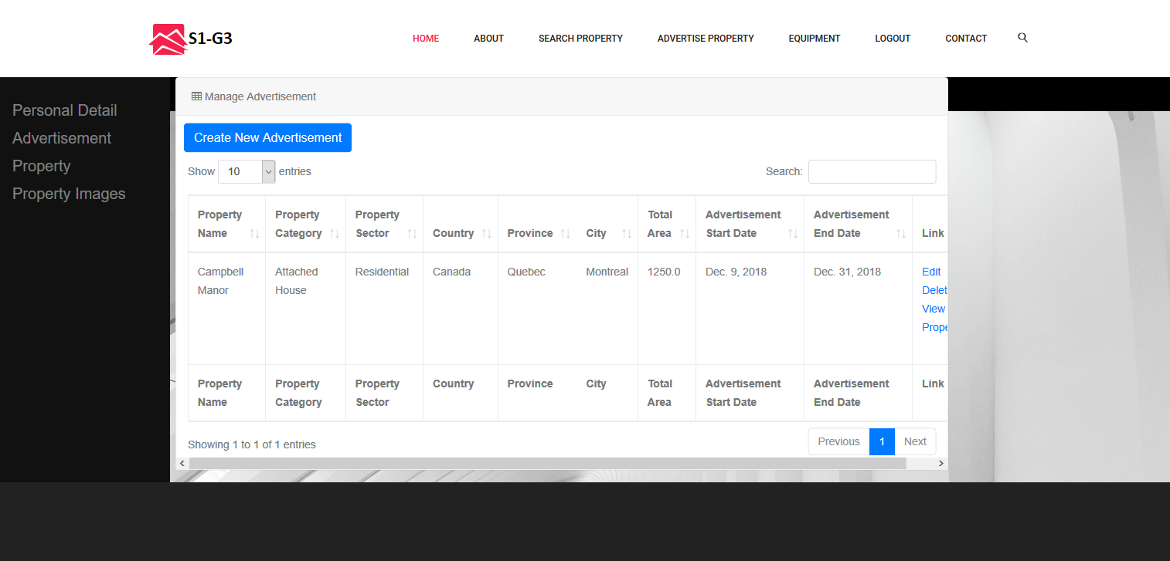

This is the page, user will see after he/she logs in. Once logged in they can create an advertisement for his/her property.

**Create Property:**

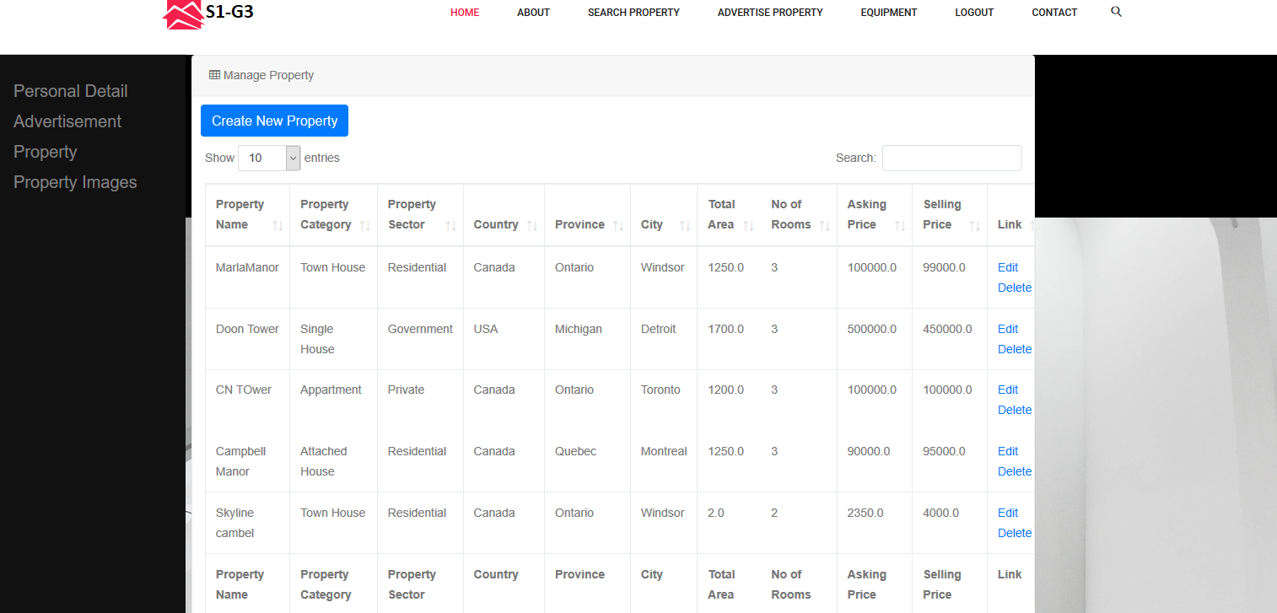

The user can see the list of all current properties they have and also can edit or modify them. Here the list is displayed in such a way that many filters can be applied for example 1)one can search for property by entering some value in the search box. 2)The properties can be filter based on the country with an ascending or descending value. 3) Similarly all columns have a arrow keys besides them which indicates ascending and descending values and can be modified accordingly.

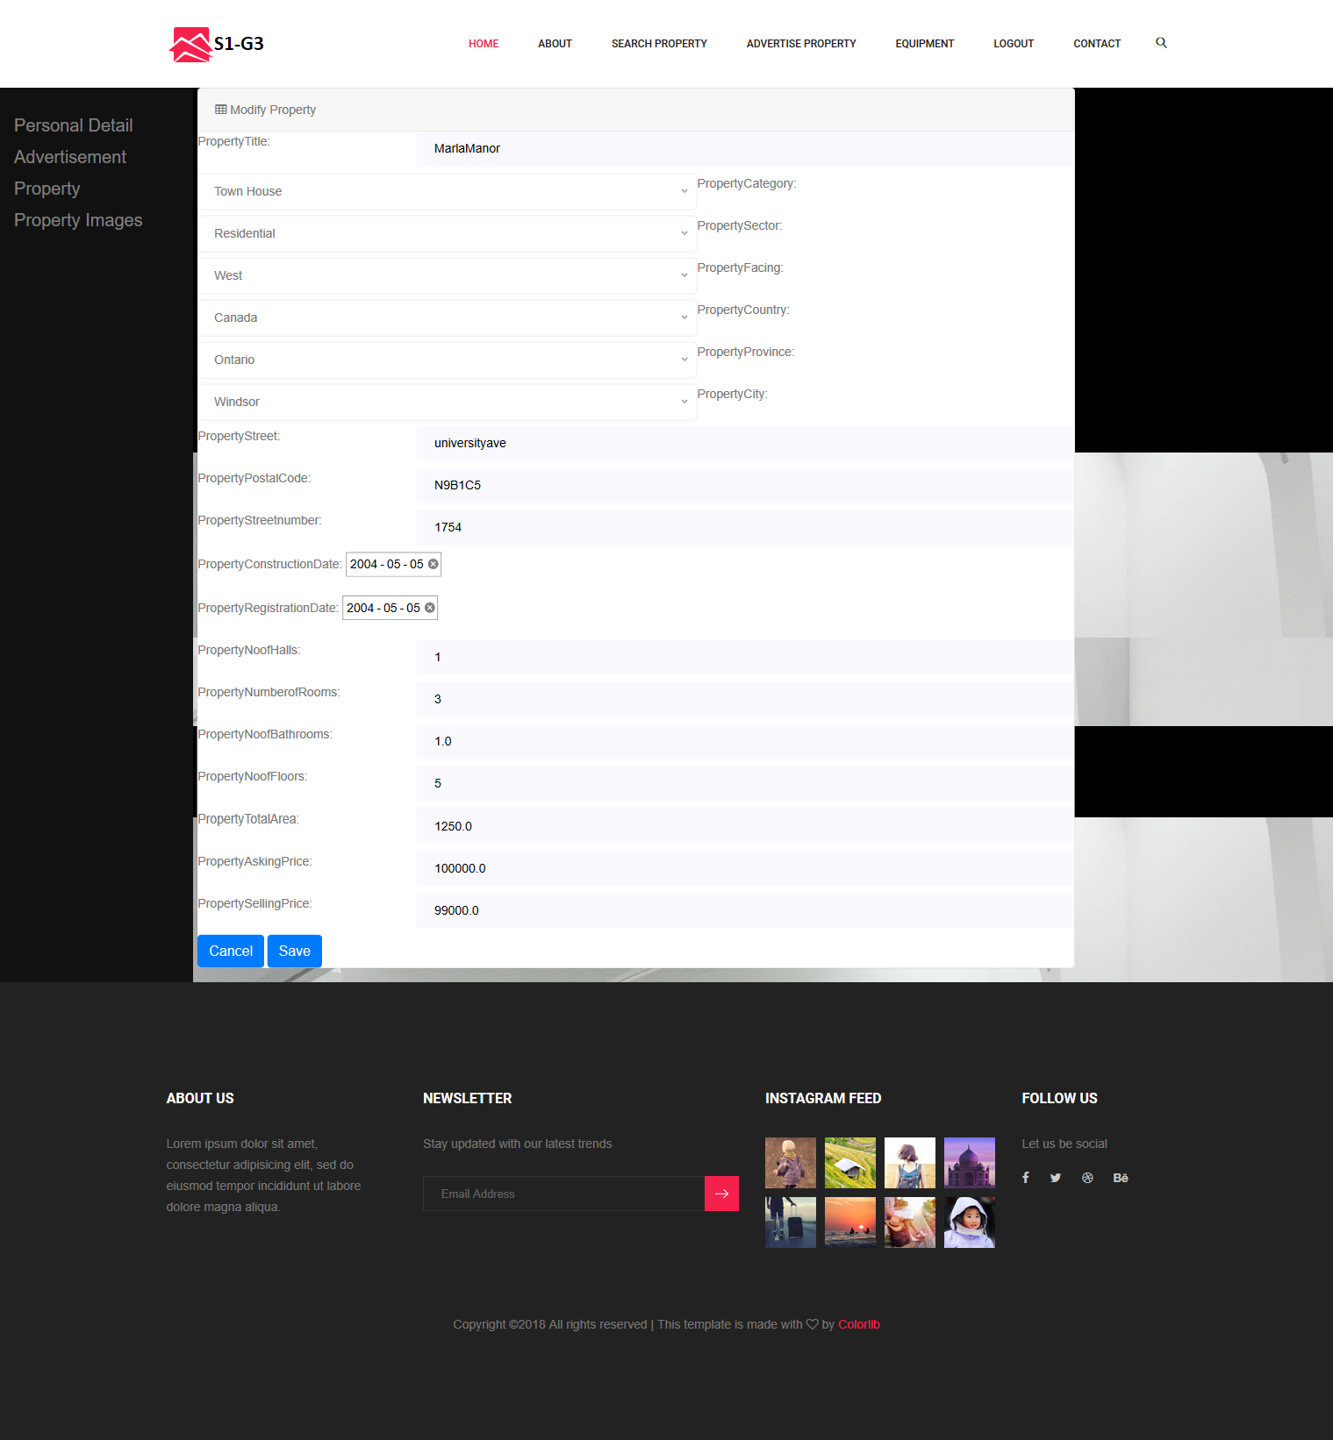

Once the edit button is clicked on the property this is what they will see. The above displayed page is the edit page for modifying a property. The website is made in such a way that all the previous values are displayed for easy usage.

**Adding Images to Properties:**

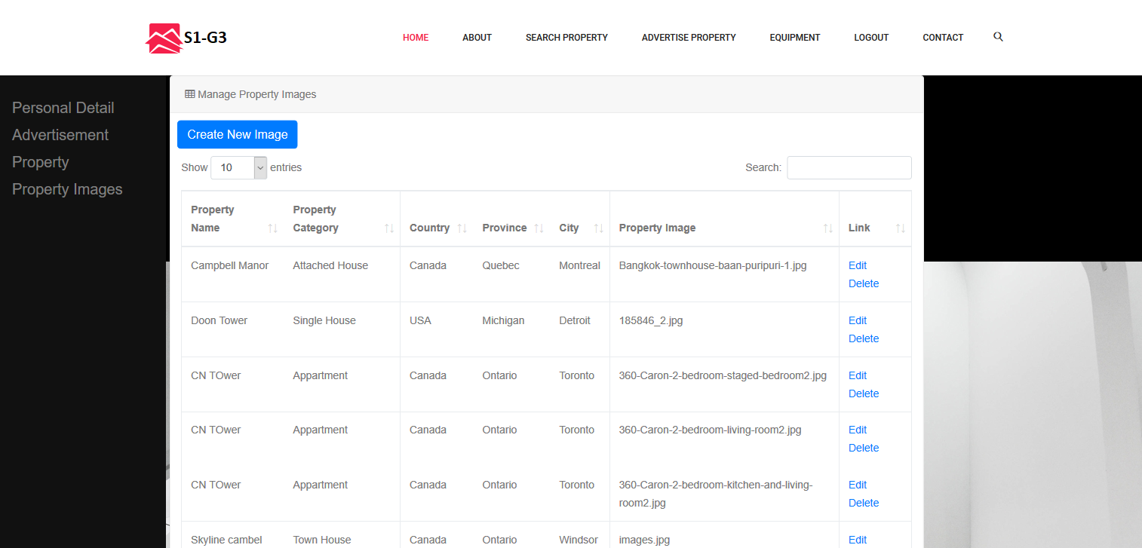

The user can add images to their properties. One property can have many number of images.

**Search Property:**

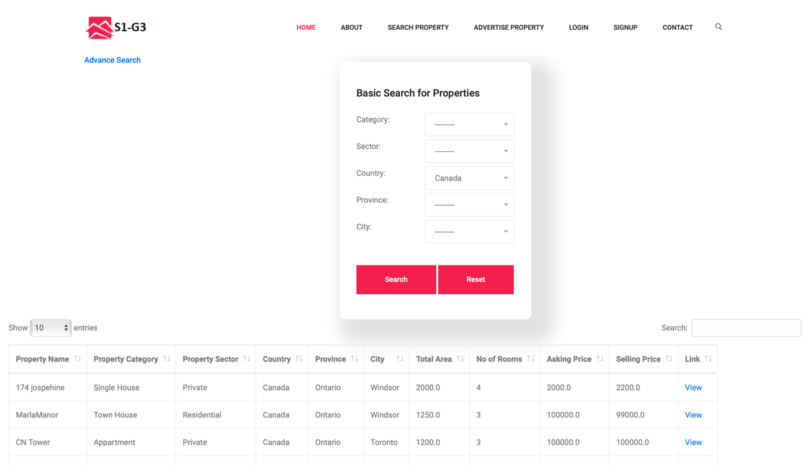

This page shows the list of available properties according to user’s search query. Here some user can click on “Search for Property” on the navigation menu and this page would be displayed. Initially if you don’t give and search parameters then a list of all available properties would be displayed.

**Search Property:**



This is result when properties are searched based on country as a parameter. Here you can see all the list of properties in Canada with its category, sector, province city and so on. The columns have small arrows besides them which indicates an ascending and descending values. For Example if you click besides the “number of rooms” column then the list would be sorted based on descending order. Also there’s a search box where the user can provide custom parameters.

**Advanced Search :**

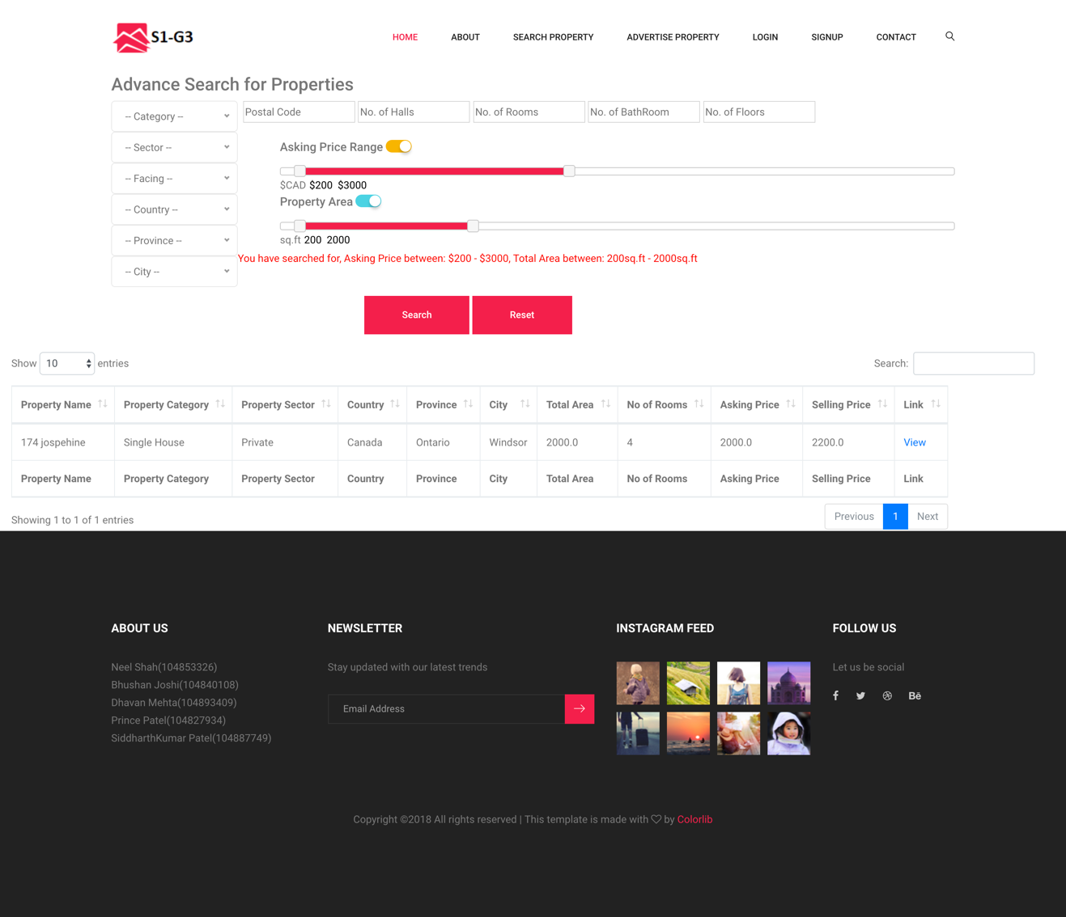

We have created a advance search page which has all the basic filters like Category, Sector etc but also few new filters such as Asking price range and Property Area. You can turn these filters on or off depending upon your requirement. Here as you can see in the image we have selected Price range between $200 to $3000 and total area between 200 sq.ft to 2000sq.f and we got 1 result which matches all the constraints provided.

**User Dashboard:**

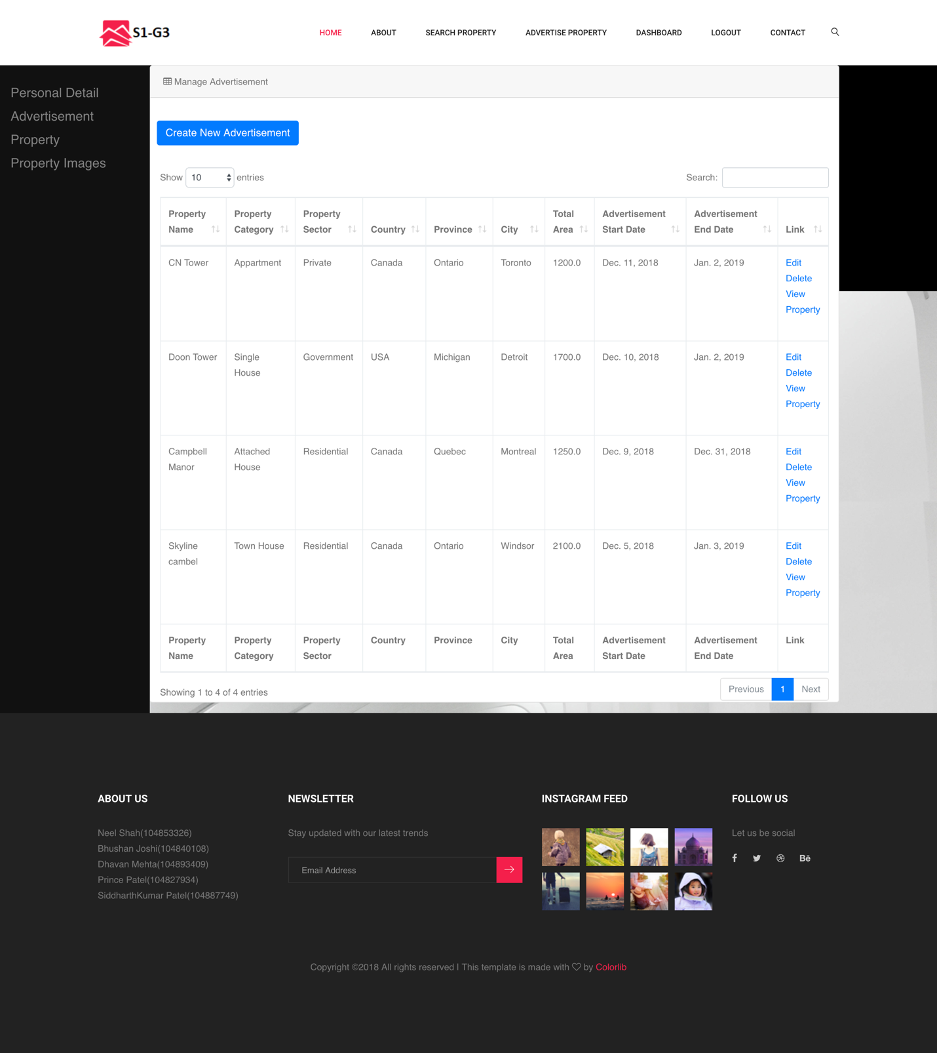

This is what the user’s dashboard would look like after they log in.

**Admin Dashboard:**

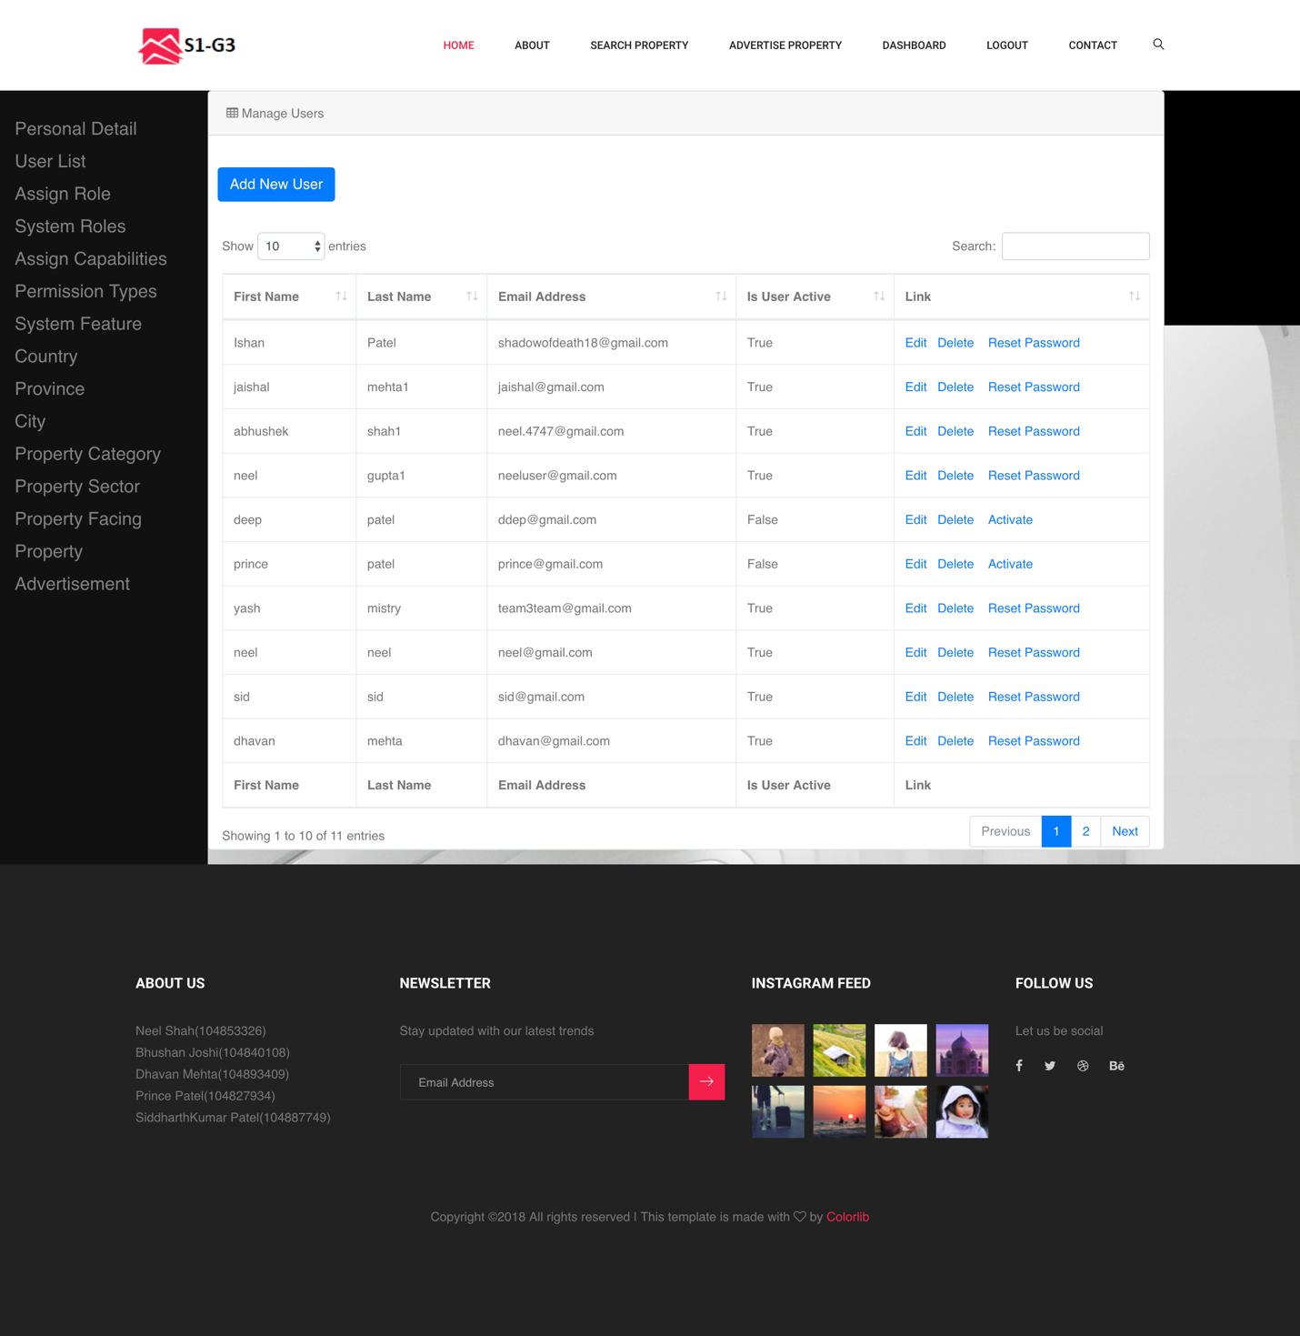

This is what the admin’s dashboard would look like after they log in.